Respected Concern,

Greetings from HAND Corp.

No doubt you’re aware that the pandemic has been a great challenge for Healthcare industry, including massive ecosystem changes. We also understand the Risk you take to treat us

To help you better plan for the times ahead, we came-up with the best possible solution



Smart and secure care

Experience the Future of Healthcare Industry with most advance, safe & secure Product, features Cloud based software for hospital management and patient care, An Application linked with software

Key features

* Avoid Unnecessary Physical contact with patients
* Enjoy Paperless patient care with most easy, user-friendly & effortless software & Application
* Best NABH compliance HIMS software, from OPD/IPD Record Management To Quality and Clinical Indicator
* A perfect example of artificial intelligence
* And everything above can be managed on your hand-hold device

Best possible solution to Implement NABH Standards in most Affordable way

**Download our App on**



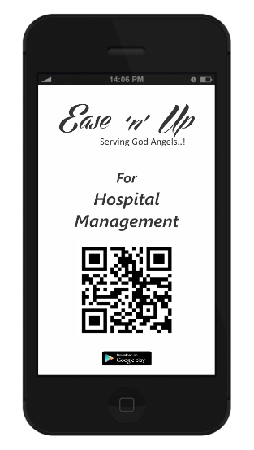 <https://play.google.com/store/apps/details?id=provider.easenup.twa>

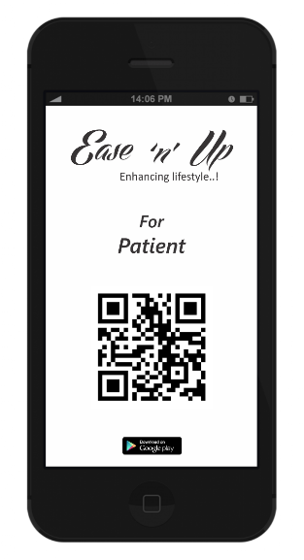 <https://play.google.com/store/apps/details?id=healthcare.easenup.twa>

**Visit us on** [**www.easenup.healthcare**](http://www.easenup.healthcare)

Please get back to us to help you leverage this channel for more Business opportunities!

Fill us in regarding whether we can plan a call to Discuss Further.

Or Feel free to contact for any further clarifications if required.

Please find the attachment

With Regards,

Team



By HAND Corp

(Hospital Associated Network Development Corporated Pvt. Ltd.)

Contact us @ +91-9335078399

OR

Mail us @ [admin@easenup.healthcare](mailto:admin@easenup.healthcare)