This agreement is made between HOSPITAL ASSOCIATED NETWORK DEVELOPMENT CORPORATED PRIVATE LIMITED (HAND Corp.) having its Registered office at B 36/43-56 Brahmanand Nagar, Durgakund, Varanasi. Providing Services to hospitals (hereinafter called as First Party or HAND Corp.)
AND
With the Company/Hospital………………………………………………………………….which is giving the consent online through its duly authorized agent on the date when it is check on online portal of www.easenup.healthcare (hereinafter referred as Second Party or client)

- About HAND Corp.
‘Hospital Associated Network Development Corporated Private Limited’ [HAND Corp.] is on a mission to help the world act differently and to achieve better health outcomes.

HAND Corp. intend to represent majority of healthcare providers globally. It is an organization advocates with the Government policies, on issues which have bearing on enabling its members organizations to deliver appropriate healthcare services to community at large.

Being a part of the “Digital India” we have launched an e-platform for Hospital as the common patient portal, which facilitates hospitals to provide various services to the patients with registered UHID (Unique Hospital Identification Number).
HAND Corp provides data interoperability between healthcare network, utilizing the latest standards, and patient-authorized access (Compliance with DISHA), to ensure the best insights across healthcare providers.
Our organization intend to build a system, entitle to support entirely digital healthcare industry. It is an API platform for - healthcare providers from health systems, Healthcare supporting industry (Hospital and Medical Furniture’s, Equipment, instruments and products), health insurance payers and Patients.

As Data interoperability, we focuses on bridging the gap between patient centered data and provider needs, thus creating a platform for patients to aggregate and share medical data from external health systems and wearable devices with providers enabling improved healthcare outcomes.

The Platform allows Members to connect data within health system electronic health records. As a member healthcare provider, you can read your users' clinical health data from patients who are registered. We believe data from external health systems is a vital, missing piece to improve care and reducing costs and data from other clinics and hospitals fills in this gap.

Our Mission and Vision

Our mission is to help all our members in healthcare industry, increase their standard through a structured, positive and professional referral marketing program that enables them to develop long-term, meaningful relationships with quality business professionals.

Our Objective

We strives to fulfil objectives, by which society and community has right to health in terms of
- Availability (quantity to meet needs).
- Accessibility (non-discriminatory and affordable).
- Acceptability (ethical).
- Quality (clinically sound).
- Affordable healthcare services.
- Ethical standards.
- Innovative medical technology and applied research.
- Patient safety, by peer evaluation mechanism based on the best practices.
- Single window solution concept.

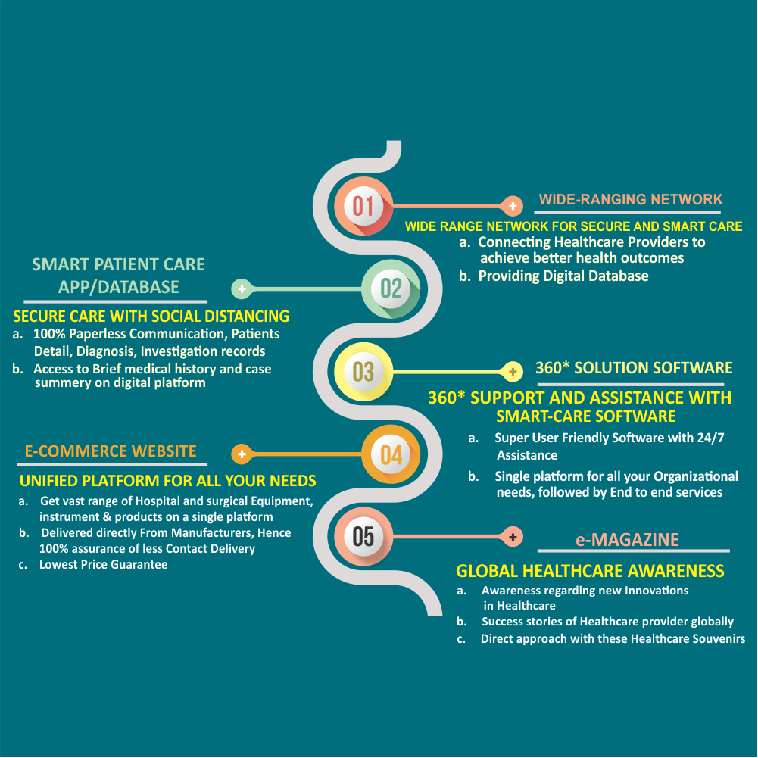
- Services Provided

At HAND Corp, we are a Member focused business network that works providing link of professionals for your business growth.

  - Management system Certification
+ ISO 9001 Certification - Quality Management System
+ ISO 14001 Certification - Environmental Management System
+ ISO 27001 - Information Security Management System
+ National Accreditation Board for Hospitals and Healthcare Providers (NABH)
+ National Accreditation Board for Testing and Calibration laboratories (NABL)
+ Joint Commission International (JCI)

  - GAP Analysis and Real Standard Audit

  - Hospital Planning & Design Consultancy

  - Power team , Merger and Acquisitions

+ Building up Power team
+ Merger and Acquisitions

  - Hospital Excellency Training
+ Medical Practice/Paramedical staff Excellency Training
+Training on Hospital infection Control
+Training on Safety and security measures
+Office Management Training

  - Process Renovation program

  - 24/7 Outsourced Process Assistance

  - Revenue Growth Management
+ Marketing Consultancy & Promotional Initiatives
+ Referral Doctors Network Promotions
+ Corporate Empanelment
+ Corporate Division Promotions
+ Health check-up camp Promotions
+ Digital & media Promotions
+ Customer Satisfaction and Public Relation

  - IT Solution
+ Website
+ Secure Storage

- Cloud-based hospital management and patient care software

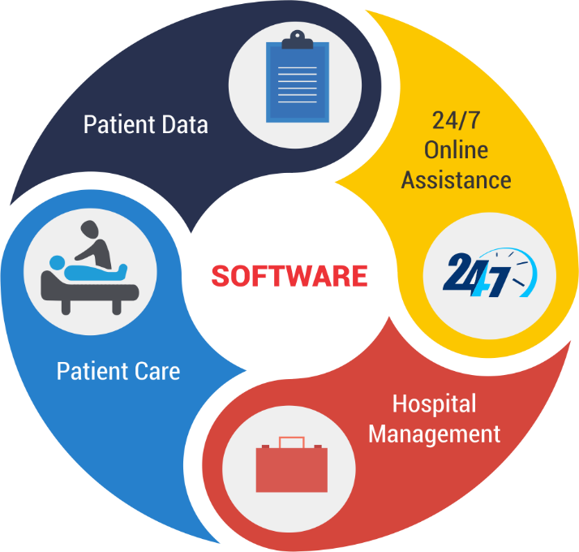

We believe to provide 360 Degree Assistance on a single platform for all your Organizational needs. Followed by end to end services for Healthcare Provides.
We have put in an enormous amount of effort to ensure our Pan India presence, in the form of multiple network service/product providers who together ensure that health care is never a challenge of any kind.
Help Hospitals build a strong network that fuels better Health Care and professional growth.
Our software is based on Hospital Information System (HIS), providing modern solution that enables medical facilities to overcome the biggest challenges in healthcare delivery today. We enables hospitals/clinics/medical centers to:-
Manage all departments, patients, and staff with ease
Improve patient care experience
Take better decision with advanced reporting features
It is a comprehensive cloud-based Hospital Information System software that is specially designed for hospitals and clinics with affordability, scalability and ease-of-use in mind. Comprehensive and rich in features, to cater every hospital needs, it is the preferred choice for healthcare providers who want a proven HIS solution.

Key Highlights


COMPREHENSIVE
All-in-one software solution fulfilling every requirement for efficient operations and management of hospital


PROVEN SOLUTION
HIS solution is a best proven platform that has been implemented in healthcare facilities.


SCALABLE
It can fulfill most of the requirements of hospitals and clinics. Our software grows with your business. As your business scale up, our solution can easily support it.


EASY-TO-USE
Built with the customer needs in mind, easy to learn and use. Functions within the modules have been tailored to meet the needs of most hospitals.


INNOVATIVE
Best Innovative solution in healthcare with focus on Speech-to-text for Clinical Staff, Interactive EMR, single click e-prescription generation, payment gateway functionality to allow Patients to pay online towards pending payments and many more


COST EFFECTIVE
Best cost efficient software, having an option of monthly payment, according to the facilities consumed.


AVAILABILITY
Our services are available 24x7 on the cloud or your internal server. We provides peace of mind and allows healthcare providers to focus on patient care

SECURITY
Experienced and skilled HIS implementation services team ensures that the HIS solution is free from security breaches. This includes protecting computers, networks, programs and data from unauthorized access or damage and data privacy is restored.


ACCESSIBILITY
Easy to access on desktop, mobile and tablets, designed with mobility in mind

- e - HAWK
B2B e-Commerce Platform

We are proud to present e-Market, single e-platform market for all your products. We act as a bridge between manufacturer and healthcare providers to fulfill the demand and supply in the direct approach basis, so called Institutional sale. For procurement of medical and surgical devices, equipment, supplies, products and consumables online in India, nothing is easier than us, we intend to be India's Largest Online Medical & Hospital Products Store. We are online Store, trusted for medical devices, suppliers and medical equipment dealers. We're a one stop online medical Equipment and devices supplier. Our online surgical supply store provides genuine Product with Superior Sourcing from medical manufacturers and medical equipment dealers/Importer, Eliminating the middle men and ensuring the best possible price for medical devices online. Healthcare provider can purchase medical equipment accessories, medical devices online and medical equipment from our online surgical supply store. Procuring Medical equipment, Medical devices, and medical equipment accessories is a tough task in some parts of India where conventional Medical Devices Suppliers and Medical equipment Dealers don't provide advanced equipment, we intend to fills this gap and provides reliable and superior quality medical devices, medical equipment’s, medical equipment accessories and surgical products online at Best Possible Price.

Key Features

Single point of contact: Direct communication and approach between the health care providers and manufacturers/Importers, hence eliminate the middle man.
Assured Quality: Online market is amongst the best medical devices manufacturers/ importers for genuine medical equipment, accessories and Devices.
Product Display: Doorstep Demonstration and delivery, assured quick turnaround time with a seamless experience.
Low cost Assurance: Superior sourcing from manufacturers ensuring best and competitive price when compared to other sellers and Dealers.
Easy payment Flow: Multiple hassle-free payment options with pre-payments through credit/debit card, online transfer or e-wallets , EMI facilities also available
Discounts/Coupons: Discounts and Exiting Deals are available while shopping for products online
24*7 support: 24*7online store with Customer support team to help you.
Easy search: Specializes in hard to find medical disposables and medical supplies
Streamline shopping experience: Easy ordering process and quick turnaround time

- ‘The Connect’
E-Magazine which provides information related to latest updates in healthcare industry and works as a social platform for hospitals and doctors to connect

e-Magazine is a ‘trusted authority’ on the latest healthcare news combining Success stories of Healthcare providers, ‘Executive Thought Leadership Interviews’ with the very latest case studies on Healthcare, Digital Health, Technology, Supply Chain & Sustainability.
Our focus is to provide our users with the ‘Ultimate Digital Experience’ - an incredible digital magazine, an world-class website, an award-winning newsletter service as well as video reports, podcasts, blogs, webinars, white papers, research reports, virtual events and a database second to none.
we also intend to offers its advertising partners a unique blend of digital branding, content syndication and executive thought leadership articles as well as a ‘gated intelligence community’ providing ultimate demand generation and measurable ‘Ad-Campaign’ ROI’s.
‘The Connect’ is read by Healthcare industry professionals at all levels, hospitals, healthcare, medical devices, pharmaceuticals, as well as technology and consulting executives.

We intend to function as communication hub and notify members on national and international affairs which may have ramifications for Indian healthcare providers. We have a resource center, which besides bringing out regular NEWS BULETTIN/E-MAGAZINE also coordinate and collate to bring out publications on topics of expertise as needed by the healthcare providers. WE have created center of excellence in knowledge management for new and Innovative medical technology and applied research.

General Conditions
  - Assess of the services will be granted as per the criteria of registration.
  - The registration includes three criteria- Silver, Gold and platinum, the detail of which is provided in the agreement.
  - A copy of set of mandatory document will be provided (Uploaded) by Hospital as per requirements. And Client shall comply with requirements.
  - In Case of Consultancy, Client shall make all necessary arrangements for the conduct of the session, including provision for examining documentation and access to all processes and areas, records.
  - Client shall make provisions, where applicable, to accommodate the presence of observers/service provider.
  - This agreement shall become a contract upon its acceptance and signing by both the parties, this agreements shall bind both of the parties and no other statements, representations or arguments, verbal or written, which contradicts to the terms and condition of this agreement is void made by either representative of the parties.
  - The online registration process shall be initiated after the acceptance of this agreement.
  - In Case of an ongoing Process, HAND Corp. shall provide detailed description of the initial and continuing activity; in its website www.easenup.healthcare

Plan Tariff:
Package | Platinum | Gold | Silver
Cloud Based Software
- Out-Patient Concern |  |  | 
- In-Patient Concern
- Management Concern
Application -Patient Concern
- Manage Appointment
- Manage out-patient treatment
- Manage In-patient treatment
- Notification and Reminder
Application-Management Concern
- OPD Management
- Manage Task
- Manage Records and Indicators
- Manage Inventory and stocks
- Manage Billing and accounts
Customization
Staff Training On Software
Personal Online Assistance
e-Magazine
e-Market
Digital promotion |  | 
Price *
Membership Registration (Annual) | 500/- | 500/- | 500/-
Installation Charges (Software) | 5000 | 2000
Annual Software Subscription | 60,000/- | 10,000/-
Terms of Payment
HAND Corp. shall inform about the fee for required services not mentioned in tariff, in its Quotation
- Invoices / Performa Invoices shall be provided to the client organization and client organization is liable to pay the stipulated amount as raised and duly accepted by the client organization for services as scheduled in the invoice at the different stages. Charges and fees shall be on the basis of the application review.

- Postponement of confirmed on-site session/training dates may result in charges up to 50 percent of scheduled on-site assessment plus all pre-paid expenses.

- In the event an account is not paid or otherwise resolved within 30 days after the date of invoice, Thereafter, interest will be become chargeable on the outstanding amount @ 18% per annum.
HAND Corp. may at its option:
- Refuse any further consideration of the agreement or
- Terminate this agreement with reasons in writing

- Fees and expenses incurred by HAND Corp. in connection with collecting past due accounts shall be the responsibility of the Organization.

- Continuity of services will depend on the outstanding invoices, been settled

- Travel expenses of Associates will be charged at actual from our nearest office. Boarding and lodging expenses shall be charged at actual where the associate/consultant is required to travel overnight.

Responsibilities of HAND Corp.

- Any information about the client received from the any person other than client like complainant/Regulators/Statutory bodies or any other person shall be treated confidential and cannot be disclosed.

- All other information, except for information that is made publicly accessible by the client, will be considered confidential by HAND Corp.

- When there is any change in the requirement of the services/Process, then HAND Corp. will send a notice to Client Company intimating the new requirement or change. The client has to Comply to notice of any changes to its requirements and verification of compliance with the new requirements

- HAND Corp. shall provide information of client’s, address standard and scope in public domain.

- Information provided by the HAND Corp. to any client or to the marketplace, including advertising, shall be accurate and not misleading.

Confidentiality

- HAND Corp. shall, through legally enforceable agreements, follow policy to safeguard the confidentiality of the information obtained or created during the performance of certification activities at all levels of its structure, including committees and external bodies or individuals acting on our behalf.

- Exceptions as may be required by Law or due to contractual obligation, Information between HAND Corp. and the Organization will treat as strictly confidential and will not disclose to any third party without prior written consent of the other, any information which comes into their possession, the possession of their employees, agents or others by virtue of this Agreement.

- In case any law or regulation required to disclose the information of the client organization or individual to a third party which is treated as confidential shall be given but the client organization or individual concerned shall be notified in advanced.

- HAND Corp. shall inform the Organization of any information other then brief particulars of the organization about that HAND Corp. shall place them, as per then existing practice covering name, relevant nominative document, scope and geographical locations in public domain. All other information, except for information that is made publically accessible by the Organization, shall be considered confidential.

- Information about the Organization from sources other then Organization i.e. complaints and regulators shall be treated as confidential, consistent with the HAND Corp’s policy.

- Personnel, including any committee members, contractors, personnel of external bodies or individuals acting on the HAND Corp’s behalf, shall keep confidential all information obtained or created during the performance of the activities.

- HAND Corp. shall ensure and having a process for the secure handling of all confidential information including documents and records held by it.

- When any confidential information is to be made available to any external bodies’, HAMD Corp shall keep the client organization informed.
Liability:
- Except, in the case of deliberate neglect on the part of HAND Corp., its employees, servants or agents, HAND Corp. shall not be liable for any loss or damage sustained by any person due to any act of omission or error whatsoever or howsoever caused during the performance / services.

- In the case of neglect, as aforesaid, the limit of any loss, damage or otherwise HAND Corp. liability will be limited to an amount not exceeding the maximum fee (if any) charged by HAND Corp. for the particular service in respect of which the neglect arose. While the restrictions on liability herein contained are considered by the parties to be reasonable in all the circumstances, if such restrictions taken together or any one of them shall be judged to be unlawful or unenforceable then the said restriction shall apply with such words deleted or amended or added.

- The provision of this clause shall not apply to any death or personal injury but the Organization shall maintain at all time adequate insurance sufficient to cover all liability that may arise as a result of any matter arising in pursuant to this Agreement.

Force Majeure:
HAND Corp. shall not be liable in any respect, should it be prevented from discharging such obligations as a result of any matter beyond its control which could not be reasonably foreseen.

Disputes:
In case of the dispute arise between the parties then it shall be settled by appointment of the sole arbitrator as The INDIAN Laws. Aggrieved party can challenge the award of arbitrator with 30 days of the award but the Jurisdiction area shall be INDIA only and the case can be filed in the competent court of INDIA only.

Payment Details:

Invoice Amount received through Cheque /Draft no. ____________ Dated ___________ Amounting Rs. ______________/- drawn in favor of Hospital Associated Network Development Corporated Pvt. Ltd.

FOR & ONBEHALF OF  HOSPITAL ASSOCIATED NETWORK DEVELOPMENT CORPORATED PVT. LTD.  ( Signature With Seal)  Name of Signatory:  Designation:  Date: | FOR & ONBEHALF OF :  ( Signature With Seal)  Name of Signatory:  Designation:  Date:

